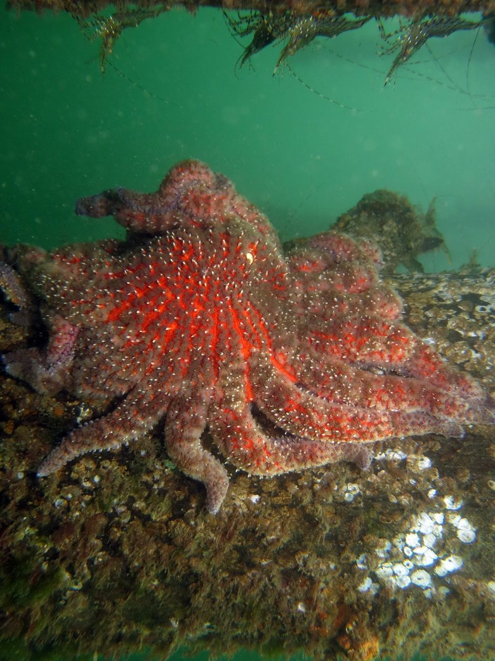The sunflower star is the Salish Sea’s fastest and largest sea star, often reaching 4 feet across, weighing up to 11 pounds and having up to 24 arms. (courtesy of Ed Gullekson)
In the case of the sunflower star, losing one key species can change the entire ecosystem.

As sunflower stars go, so goes the health of our seas
Originally published January 30, 2019 at 5:01 am Updated January 31, 2019 at 7:32 am
By
Drew Harvell
and
Joseph K. Gaydos
Special to The Times
Starfish don’t have big eyes and long lashes like baby harbor seals. They don’t even take care of their young like killer whales, but in children’s eyes they are still stars of the ocean. When the sea star wasting disease epidemic hit the West Coast in 2013, people were devastated to see the common orange or purple ochre stars melting away when they walked beaches. Fortunately this year, this once most abundant intertidal sea star may be slowly recovering in our region.
Since not that many people scuba dive in the cold waters of the Salish Sea, few people in 2013 saw the simultaneous disappearance of the deeper dwelling sunflower sea star. The sunflower star is not only the fastest sea star in our region, it is also the largest, often reaching 4 feet across, weighing up to 11 pounds and having up to 24 arms. Before 2013, it was as common as a robin. It is considered a keystone predator because it can shape the ecosystem. What might be surprising to some is that this most common deep water star was also the most susceptible to disease and the hardest hit.
Unlike the intertidal ochre star, the deeper dwelling sunflower star is not recovering. This week we released a paper, showing catastrophic and continuing decline of the sunflower star from Alaska to California, its entire range. Data from thousands of National Oceanic and Atmospheric Administration deep-water trawls from Mexico to the Canadian border also showed that the sunflower star is absent in deep water too. We think it is time to consider listing the sunflower star as an endangered species. It is absent in the southern part of its range and rare elsewhere where it continues to decline from the disease. But the U.S. Federal Endangered Species Act (ESA) is under attack. The Trump administration is working to strip the law of key provisions, a move that conservationists say would weaken a law enacted 45 years ago to keep plant and animal species in decline from going extinct.
Why propose listing of a species that nobody’s even heard of when imperiled species like whales and salmon are not being funded? Sure, every species matters, but the “every species matters” argument is not a very strong one against people who want to dismantle the ESA for everything from the Oahu tree snail to southern resident killer whale. In the case of the sunflower star, losing one key species can change the entire ecosystem.
Sunflower stars prefer to eat clams, but they also eat sea urchins. After the 2013 sea star wasting disease outbreak, death of most sunflower stars resulted in a rapid increase in urchins in California as well as our waters in the Strait of Juan de Fuca, the San Juan Islands, Washington’s outer coast and the Strait of Georgia, including Howe Sound, British Columbia, just north of Vancouver. In Howe Sound, kelp declined dramatically as urchins, now free of a major predator, overgrazed the bull kelp. Now this same process has played out in California: The sunflower star is gone, and urchins have exploded and overgrazed valuable kelp beds, with impacts to California fisheries. With the loss of kelp comes a loss in biodiversity, and that means a change in the entire ecosystem, including critical fish habitat.
The ESA is not just a law to save bald eagles, killer whales and other charismatic megafauna. Keeping species from going extinct helps support entire ecosystems — ecosystems we depend on for not only recreation and quality of life, but also for healthy food and a strong economy. When ecosystems are better off, we are all better off, and that’s why we think proposing listing of the little known sunflower sea star as endangered under the U.S. Federal ESA is not only good for the sunflower star, but for all of us.
Drew Harvell is a professor of marine ecology at Cornell University and author of the upcoming book "Ocean Outbreak: Confronting the Rising Tide of Marine Disease." She is an affiliate faculty in School of Aquatic and Fishery Sciences at the University of Washington and resident at Friday Harbor Labs.
Joseph K. Gaydos is a wildlife veterinarian and science director for the SeaDoc Society, a program of the UC Davis Wildlife Health Center that has a regional focus on improving the health of the Salish Sea.

